**KML Converter Instructions –**

**Starting the program-**

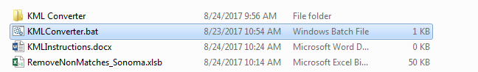

Double click on KMLConverter.bat to start the program.

**Convert KML to KMLCSV -**

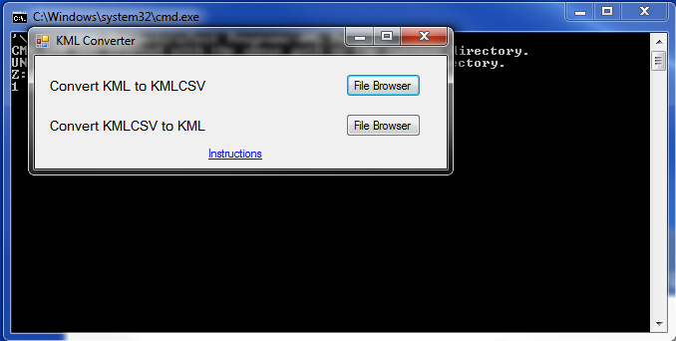

Click on File Browser next to Convert KML to KMLCSV on the main window

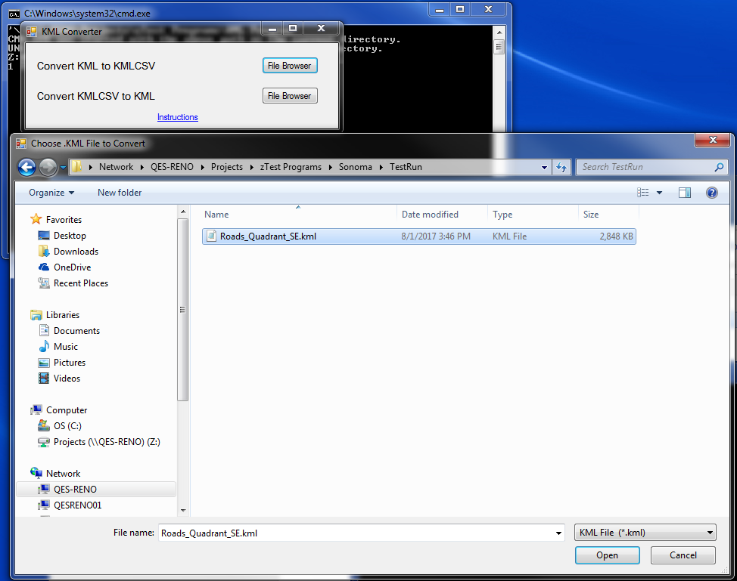

Choose the KML file you wish to convert.

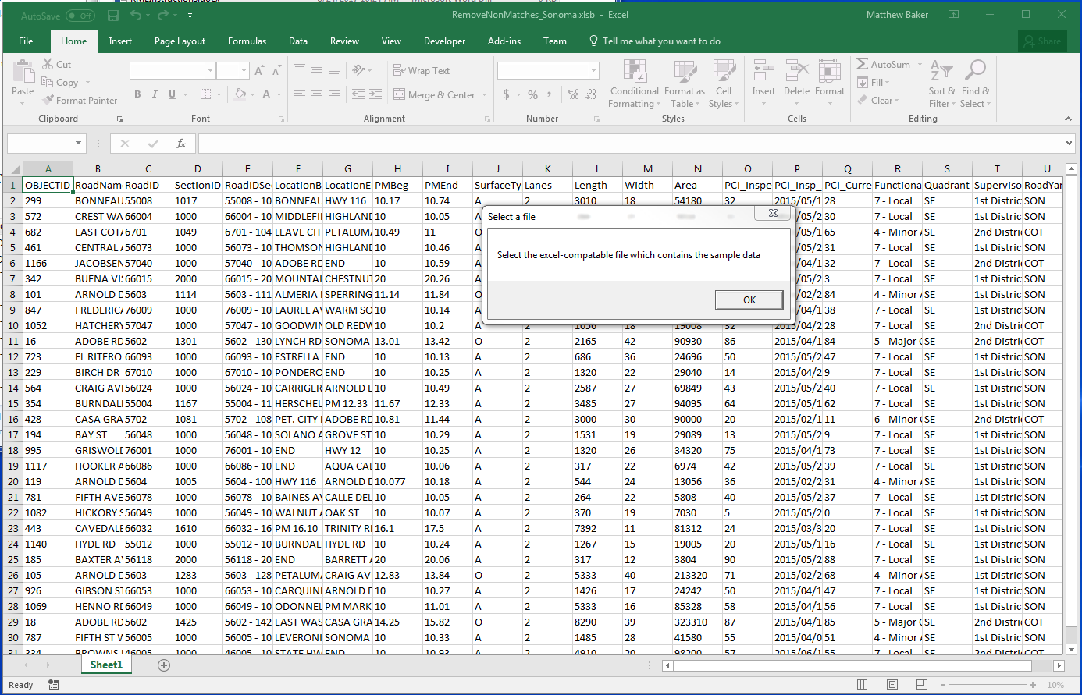

Excel will open and ask for the excel file that contains sample data.

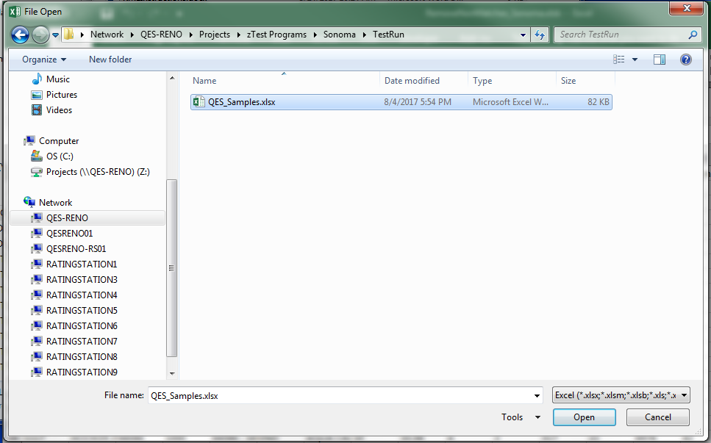

Choose the file that contains the sample data.

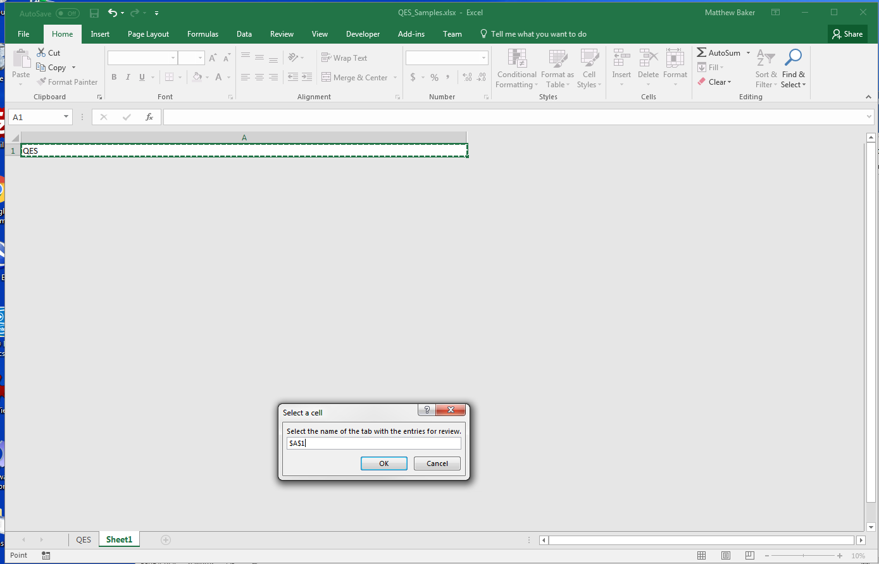

Select the name of the tab with the entries.

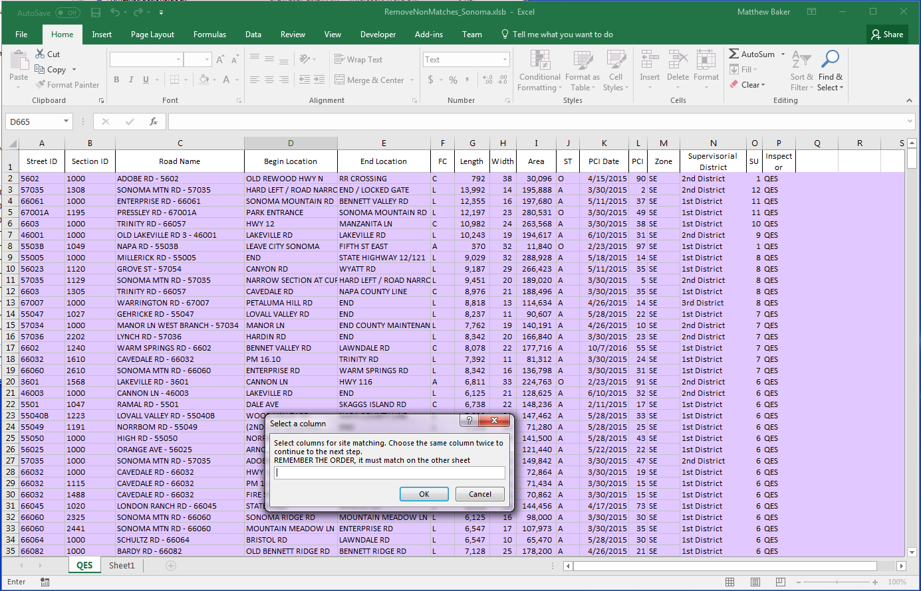

Choose the columns for matching. Choosing the same column twice will continue on to the next step. Remember the order.

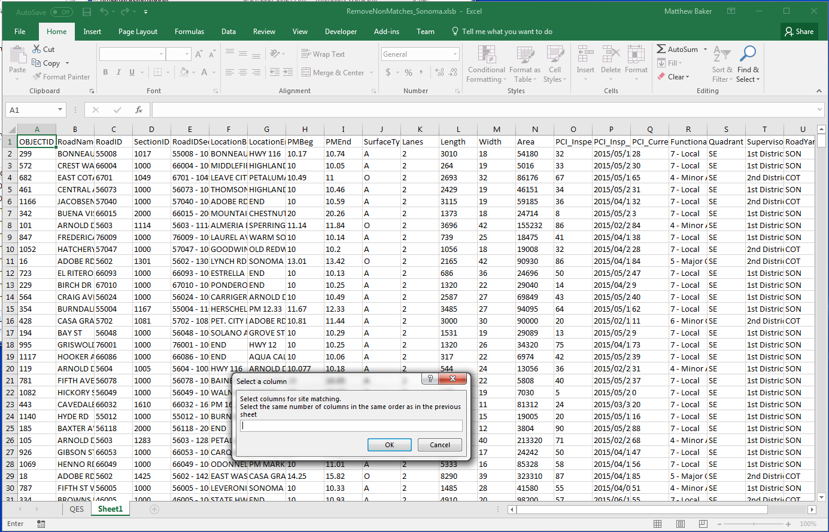

On the next step, choose the same columns in the same order as above. Again choose the last column twice to continue on.

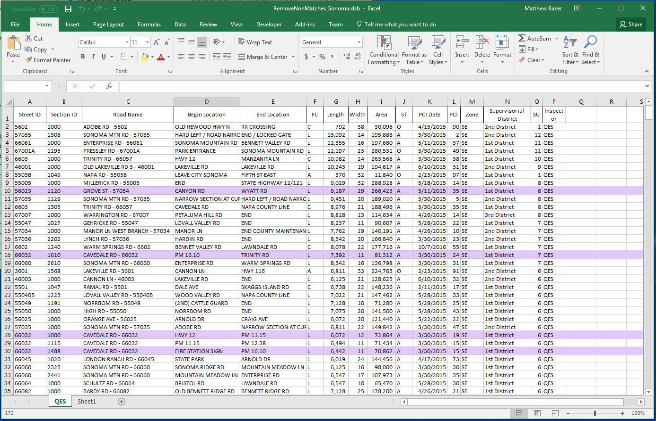

Excel will then start highlighting matches.

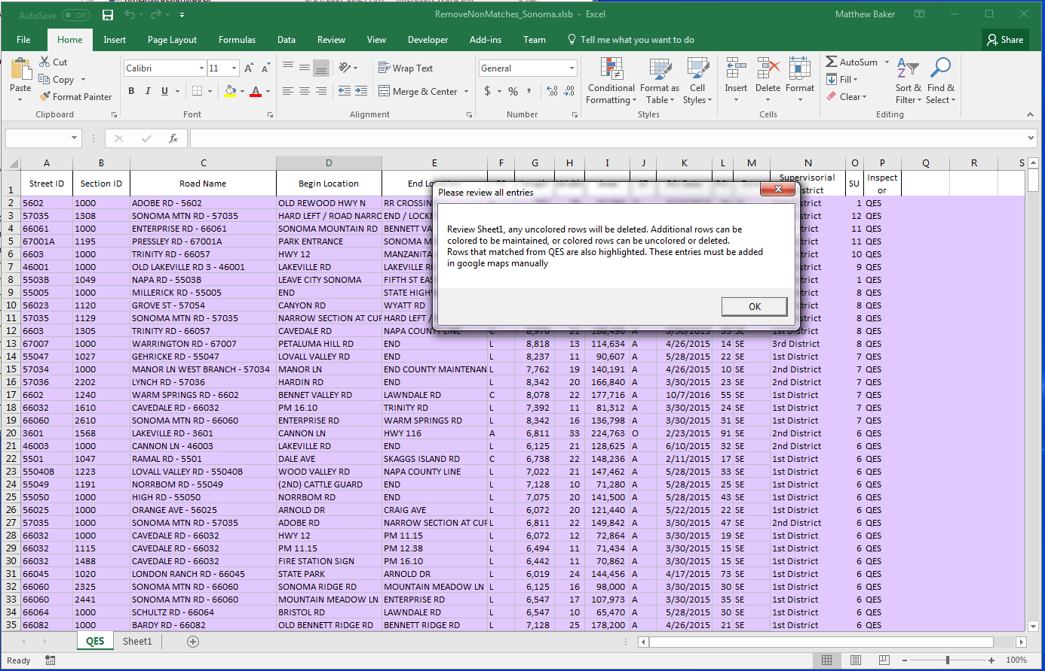

Once excel finishes, a pop up will ask for you to review sheet1. The uncolored roads will be deleted. Click OK.

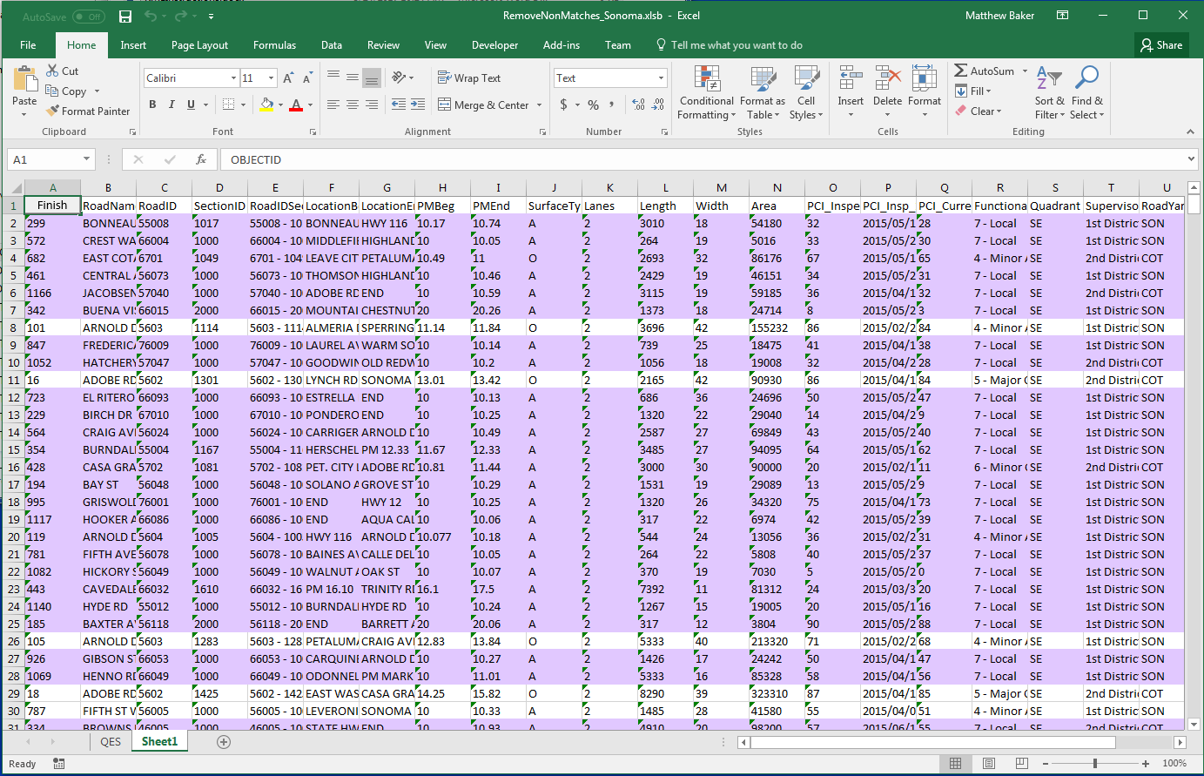

There is a button in the top left corner of Sheet1. Once you are done reviewing the sheet click “Finish”.

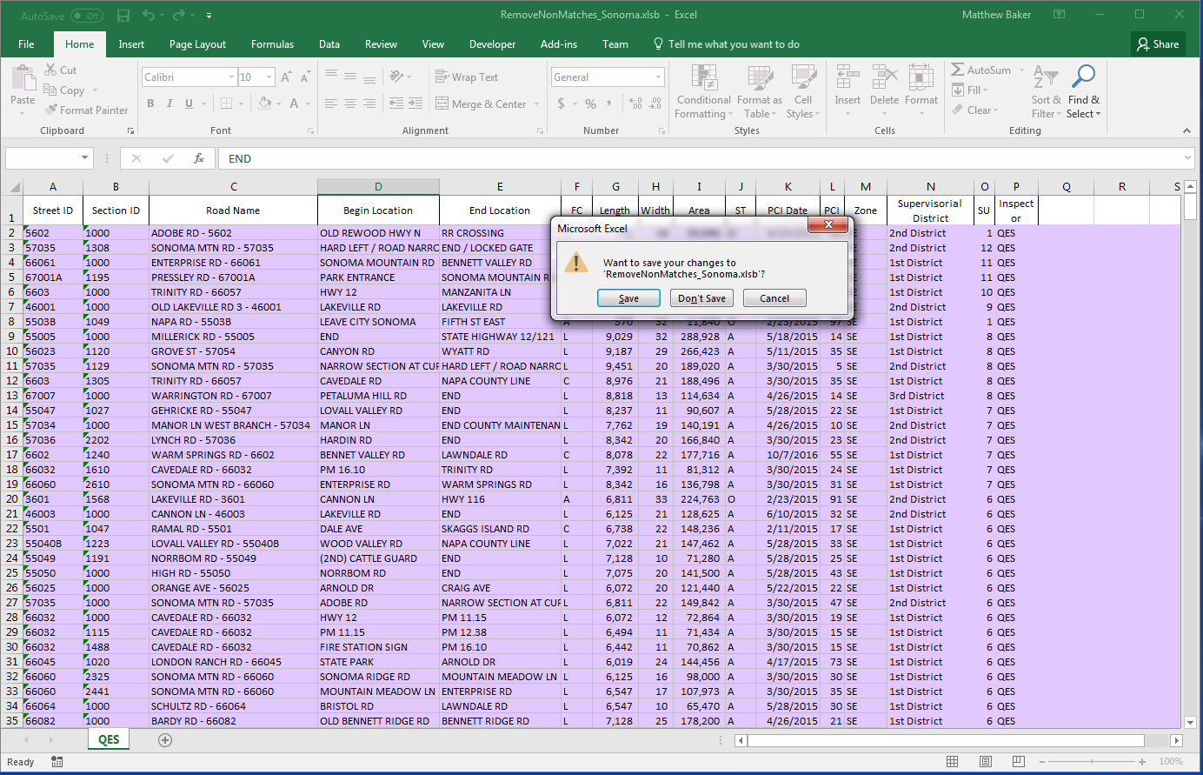

Click “Don’t Save” as this will modify the original file.

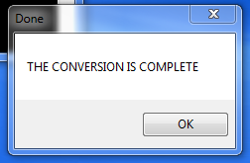

The main window will notify that the KML file has been converted to KMLCSV.

**Convert KMLCSV to KML -**

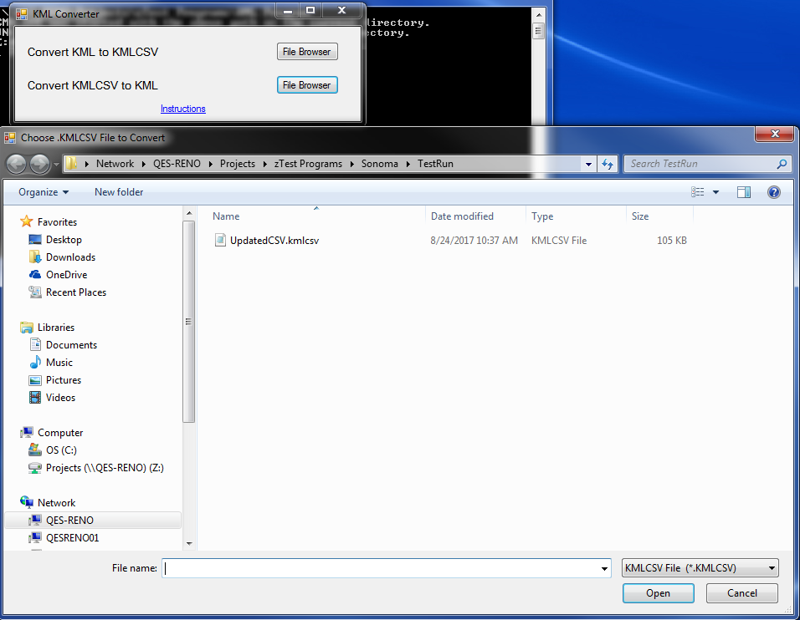

Click on File Browser and choose the KMLCSV file that you wish to convert. It will usually be named UpdatedCSV.kmlcsv.

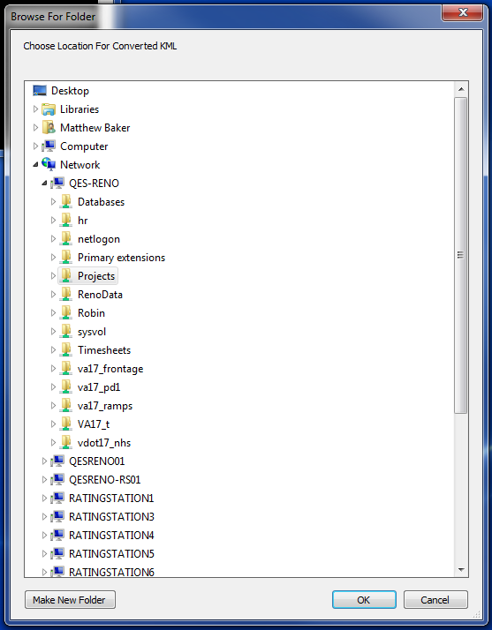

Choose the folder that you want the new KML file to be located.

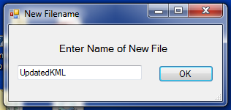

Enter a new name for the KML file. The default name is UpdatedKML,

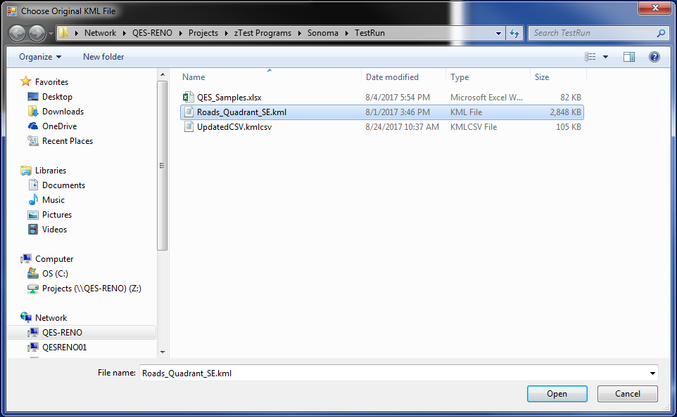

Choose the original KML file that the UpdatedCSV.kmlcsv is based off of and click “Open”.

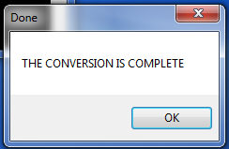

Once the conversion is complete, the main window will notify saying that it is done.

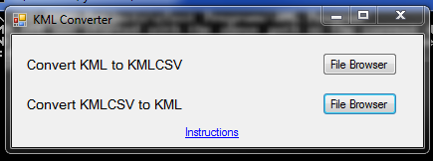

Once done with the program, click the X on the main window. The command prompt window behind it will automatically close.